One way only

Normal Form

**1st normal form**  by splitting out the location

Which is the primary key? The best primary key is title+location but a movie primary key should be only the title

Ant man does not have direct relationship with Burbank but rather with Walt

Different states

Transaction 2 happened first and A have 300 however transaction 1 started so B have 300 and A have 200. Transaction then retrieve B which is 300 however the total became 600 whereas the actual state is 500. The state became inconsistent as the state has never been 600.

To solve inconsistent state

Locking the db

Malice and accidental damage

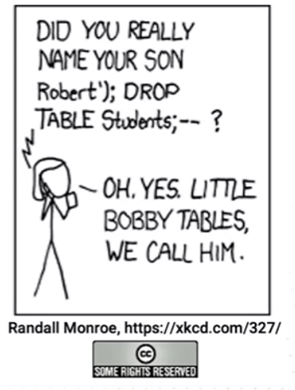

Can give other user privileges

Revoke the privileges

Create a role with privileges that can be used to give to users.

